# Exam 3 Part 2

**Problem 1:**

% Speed readings

speed_readings = [61 59 57 43 76 74 82 86 73 32 21 56 62 63 62 72 83 24 43 22 35 54 65 45 42 67 43 46 23 15];

% Q1. Sample Mean

mean_speed = mean(speed_readings);

disp(['Q1. Sample Mean: ' num2str(mean_speed)]);

% Q2. Sample Mean-Square

mean_square_speed = meansqr(speed_readings);

disp(['Q2. Sample Mean-Square: ' num2str(mean_square_speed)]);

% Q3. Sample RMS (Root Mean Square)

rms_speed = rms(speed_readings);

disp(['Q3. Sample RMS: ' num2str(rms_speed)]);

% Q4. Sample Variance

var_speed = var(speed_readings);

disp(['Q4. Sample Variance: ' num2str(var_speed)]);

% Q5. Sample Standard Deviation

std_dev_speed = std(speed_readings);

disp(['Q5. Sample Standard Deviation: ' num2str(std_dev_speed)]);

% Q6. Sample Median

median_speed = median(speed_readings);

disp(['Q6. Sample Median: ' num2str(median_speed)]);

% Q7. Sample Mode

mode_speed = mode(speed_readings);

disp(['Q7. Sample Mode: ' num2str(mode_speed)]);

% Q8. Sample Range

range_speed = range(speed_readings);

disp(['Q8. Sample Range: ' num2str(range_speed)]);

**Q1. Sample Mean: 52.8667**

**Q2. Sample Mean-Square: 3186.8**

**Q3. Sample RMS: 56.4517**

**Q4. Sample Variance: 405.4299**

**Q5. Sample Standard Deviation: 20.1353**

**Q6. Sample Median: 56.5**

**Q7. Sample Mode: 43**

**Q8. Sample Range: 71**

**Problem 2:**

% Given data

F = [0 8.8 20.3 29.1 39.3 51.4 59.4 71.2];

x = [0 5.8 9.5 16.2 20.2 25.3 29.5 34.8];

% Q9. Find the value of coefficient 1a

coefficients = polyfit(x, F, 1);

a1 = coefficients(1);

disp(['Q9. Coefficient 1a: ' num2str(a1)]);

% Q10. Find the value of coefficient 0a

a0 = coefficients(2);

disp(['Q10. Coefficient 0a: ' num2str(a0)]);

% Q11. Find the value of deformation (mm) for F=65 N

F_value = 65;

deformation = polyval(coefficients, F_value);

disp(['Q11. Deformation for F=65 N: ' num2str(deformation)]);

% Plotting the best-fitting straight line and actual data

figure;

plot(x, F, 'o', 'DisplayName', 'Actual Data');

hold on;

fitted_line = polyval(coefficients, x);

plot(x, fitted_line, '-', 'DisplayName', 'Best-Fitting Line');

xlabel('Deformation (mm)');

ylabel('Force (N)');

title('Best-Fitting Straight Line for F versus x');

legend('show');

grid on;

**Q9. Coefficient 1a: 2.0617**

**Q10. Coefficient 0a: -1.4767**

**Q11. Deformation for F=65 N: 32**

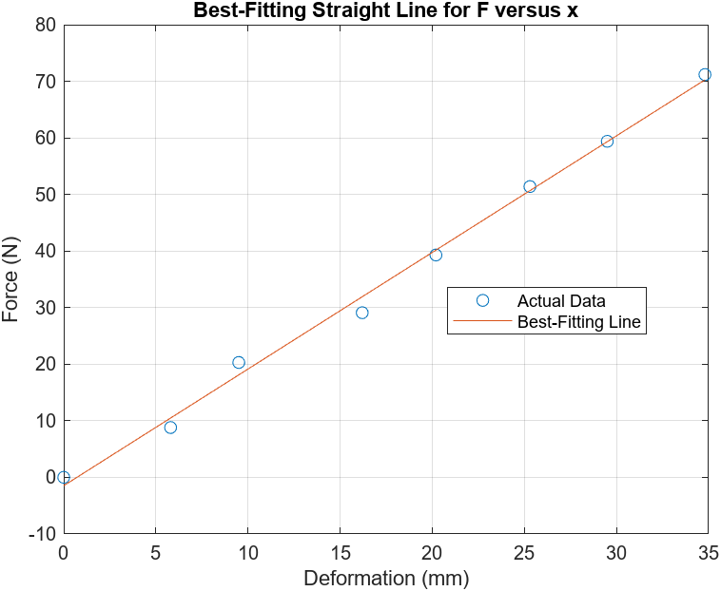

**Problem 3:**

% Q12. Find the value of coefficient 2a

coefficients_second_degree = polyfit(x, F, 2)

a2 = coefficients_second_degree(1);

disp(['Q12. Coefficient 2a: ' num2str(a2)]);

% Q13. Find the value of coefficient 1a

a1_second_degree = coefficients_second_degree(2);

disp(['Q13. Coefficient 1a: ' num2str(a1_second_degree)]);

% Q14. Find the value of coefficient 0a

a0_second_degree = coefficients_second_degree(3);

disp(['Q14. Coefficient 0a: ' num2str(a0_second_degree)]);

% Q15. Find the value of force F for x=23.5 mm

x_value = 23.5;

force_at_x = polyval(coefficients_second_degree, x_value);

disp(['Q15. Force F for x=23.5 mm: ' num2str(force_at_x)]);

% Plotting the best-fitting second degree polynomial and actual data

figure;

plot(x, F, 'o', 'DisplayName', 'Actual Data');

hold on;

fitted_curve = polyval(coefficients_second_degree, x);

plot(x, fitted_curve, '-', 'DisplayName', 'Best-Fitting Second Degree');

xlabel('Deformation (mm)');

ylabel('Force (N)');

title('Best-Fitting Second Degree Polynomial for F versus x');

legend('show');

grid on;

**Q12. Coefficient 2a: 0.0067812**

**Q13. Coefficient 1a: 1.8259**

**Q14. Coefficient 0a: -0.29308**

**Q15. Force F for x=23.5 mm: 46.3611**

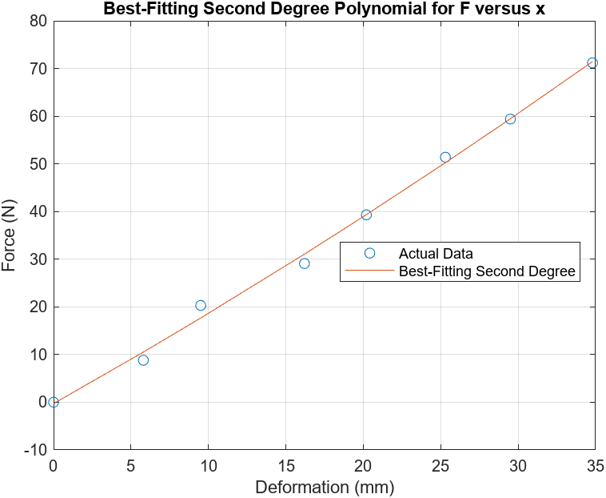

**Problem 4:**

% Given vectors

A = [2, 3, 6];

B = [4, -2, -3];

C = [4, 6, 2];

D = [-3, -6, -1];

% Q16. Length of vector B

length_B = norm(B);

disp(['Q16. Length of vector B: ' num2str(length_B)]);

% Q17. Length of vector D

length_D = norm(D);

disp(['Q17. Length of vector D: ' num2str(length_D)]);

% Q18. Scalar product B * D

scalar_product_BD = dot(B, D);

disp(['Q18. Scalar product B * D: ' num2str(scalar_product_BD)]);

% Q19. Angle between vectors B and D [rad]

angle_rad_BD = acosd(dot(B, D) / (norm(B) * norm(D)));

disp(['Q19. Angle between vectors B and D [rad]: ' num2str(angle_rad_BD)]);

**Q16. Length of vector B: 5.3852**

**Q17. Length of vector D: 6.7823**

**Q18. Scalar product B * D: 3**

**Q19. Angle between vectors B and D [rad]: 85.2885**

**Problem 5:**

% Given vectors

A = [2, 3, 6];

B = [4, -2, -3];

C = [4, 6, 2];

D = [-3, -6, -1];

% Cross product A x C

cross_product_AC = cross(A, C)

% Q20. x component of A x C vector

x_component_AC = cross_product_AC(1);

disp(['Q20. x component of A x C vector: ' num2str(x_component_AC)]);

% Q21. y component of A x C vector

y_component_AC = cross_product_AC(2);

disp(['Q21. y component of A x C vector: ' num2str(y_component_AC)]);

% Q22. z component of A x C vector

z_component_AC = cross_product_AC(3);

disp(['Q22. z component of A x C vector: ' num2str(z_component_AC)]);

**Q20. x component of A x C vector: -30**

**Q21. y component of A x C vector: 20**

**Q22. z component of A x C vector: 0**

**Problem 6:**

% Given vectors

A = [2, 3, 6];

B = [4, -2, -3];

C = [4, 6, 2];

D = [-3, -6, -1];

% Triple scalar product (C x B) * A

triple_scalar_product = dot(cross(C, B), A);

disp(['Q23. Triple scalar product (C x B) * A: ' num2str(triple_scalar_product)]);

**Q23. Triple scalar product (C x B) * A: -160**